VISTA Seminar

Seminar 61

December 6, 2023

10:00 am – 11:30 am EST / 3:00 – 4:30 pm GMT London / 4:00 pm – 5:30 pm CET Paris / 11 pm CST Beijing

TOC:

1. Presenter 1: Prof. Oleg Prezhdo, University of Southern California, USA. page 2

2. Presenter 2: Dr. Thomas Fay, University of Berkeley, USA…...…..………page 4

3. How to connect………………………………………………………..….. page 5

**Nonadiabatic Molecular Dynamics with Machine Learning**

Oleg V. Prezhdo

*University of Southern California, Los Angeles, USA*

*Email:* [*prezhdo@usc.edu*](mailto:prezhdo@usc.edu)

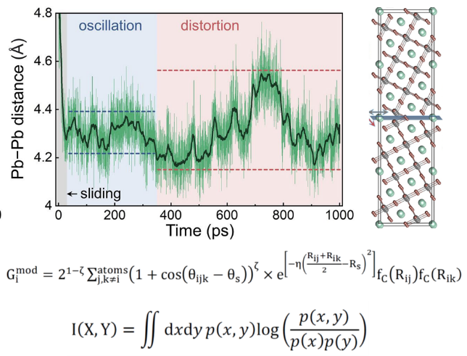

Machine learning (ML) provides tools to both accelerate [1-4] and analyze [5-7] nonadiabatic (NA) molecular dynamics (MD) simulations.

Ab initio quality ML force fields (FF) allow us to perform long MD simulations and observe rare atomic rearrangements. A 100 ps structural rearrangement of a metallic particle on a 2D substrate creates a long-lived hot-electron state that can rationalize plasmon driven photochemistry commonly catalyzed by metallic nanocrystals [1]. Fluctuations of structure of metal halide perovskites (MHPs) around point defects lead to appearance of very deep trap levels that can be both detrimental and beneficial for optoelectronic performance [2]. Sliding and distortions of grain boundaries in MHPs take nanoseconds and have a significant influence on charge carrier lifetimes [3].

To accelerate NA-MD simulation we use the MD trajectory generated with a ML force field, to compute NA couplings for a small fraction (2%) of geometries along the trajectory and interpolate the NA coupling for the remaining 98% geometries. This is particularly important for MHPs that exhibit complex MD with strongly anharmonic motions and many timescales. The method generates accurate NA-MD results with over an order of magnitude computational saving. [4]

We use unsupervised ML to analyze NA-MD and uncover nontrivial correlations [5-7]. The I-I-I angle is the key structural parameter in MAPbI3 [6] and CsPbI3 [7], the most popular MHPs, governing the NA coupling and the bandgap, although the Pb-I-Pb angle is discussed most. We discover that, surprisingly, MHP structure is much more important that motions, even though the NA coupling depends explicitly on atomic velocity. Also surprisingly, the MA+ and Cs+ cations strongly influence charge carrier dynamics, even though they do not contribute to electron and hole wavefunctions.

Combining supervised and unsupervised ML [5], we show that mutual information can be used for feature selection and significant reduction of dimensionality of ML models of NA Hamiltonians. Focusing on CsPbI3 we uncovered that chemical environment of a single element is sufficient in predicting the NA Hamiltonian. The analysis allows us to reduce a typical 360-parameter model used for a ML force-field to just a 12-parameter NA Hamiltonian model.

NA-MD is a valuable tool for studying excited state processes. Overcoming its high computational cost through simple ML models allow us to streamline NA-MD simulations, and expand accessible system size and simulation time.

**References:**

1. W. Chu, W. A. Saidi, O. V. Prezhdo, “Long-Lived Hot Electron in a Metallic Particle for Plasmonics and Catalysis: Ab Initio Nonadiabatic Molecular Dynamics with Machine Learning”, *ACS Nano*, **14**, 10608 (2020); DOE: 10.1021/acsnano.0c04736
2. B. P. Wang, W. B. Chu, Y. F. Wu, D. Casanova, W. A. Saidi, O. V. Prezhdo, “Electron-Volt Fluctuation of Defect Levels in Metal Halide Perovskites on a 100 Ps Time Scale”, *J. Phys. Chem. Lett.*, **13**, 5946-5952 (2022); DOI: 10.1021/acs.jpclett.2c01452.
3. D. Y. Liu, Y. F. Wu, A. S. Vasenko, O. V. Prezhdo, “Grain Boundary Sliding and Distortion on a Nanosecond Timescale Induce Trap States in CsPbBr3: Ab Initio Investigation with Machine Learning Force Field”, *Nanoscale*, **15**, 285-293 (2022); DOI:10.1039/d2nr05918e
4. B. Wang, W. Chu, A. Tkatchenko, O. V. Prezhdo “Interpolating Nonadiabatic Molecular Dynamics Hamiltonian with Artificial Neural Networks”, *J. Phys. Chem. Lett.*, **12**, 6070 (2021); DOE: 10.1021/acs.jpclett.1c01645
5. W. B. How, B. Wang, W. Chu, A. Tkatchenko, O. V. Prezhdo “Significance of Chemical Environment of an Element in Non-Adiabatic Molecular Dynamics: Feature Selection and Dimensionality Reduction with Machine Learning”, *J. Phys. Chem. Lett*, **12**, 12016 (2021); DOI10.1021/acs.jpclett.1c03469
6. G. Q. Zhou, W. Chu, O. V. Prezhdo, “Structural Deformation Controls Charge Losses in MAPbI3: Unsupervised Machine Learning of Nonadiabatic Molecular Dynamics”, *ACS Energ. Lett.*, **5**, 1930 (2020); DOI: 10.1021/acsenergylett.0c00899.
7. S. M. Mangan, G. Q. Zhou, W. Chu, O. V. Prezhdо, “Correlation Between Structural and Electronic Properties of CsPbI3: Unsupervised Machine Learning of Nonadiabatic Molecular Dynamics”, *J. Phys. Chem. Lett.* **12**, 8672 (2021); DOI: 10.1021/acs.jpclett.1c02361.

**Coupled electron and energy transfer dynamics in light harvesting complexes: a hybrid hierarchical equations of motion approach**

Thomas P. Fay, David T. Limmer

*University of California Berkeley, USA; Email:* [*thomas.fay@berkeley.edu*](mailto:thomas.fay@berkeley.edu)

 

In this talk I will describe a method for simulating exciton dynamics in protein–pigment complexes, including effects from charge transfer as well as fluorescence. The method combines the hierarchical equations of motion, which are used to describe quantum dynamics of excitons, and the Nakajima–Zwanzig quantum master equation, which is used to describe slower charge transfer processes. We have studied the charge transfer quenching in light harvesting complex II, a protein postulated to control non-photochemical quenching in many plant species. Our calculations reveal that the exciton energy funnel plays an important role in determining quenching efficiency, a conclusion we expect to extend to other proteins that perform protective excitation quenching.

**How to connect**

Alexey Akimov is inviting you to a scheduled Zoom meeting.

Topic: VISTA, Seminar 61

Time: Dec 6, 2023 10:00 AM Eastern Time (US and Canada)

Join Zoom Meeting

<https://buffalo.zoom.us/j/96465847706?pwd=TG14ZHpjTHlaQzZmNDluTkRyck5GQT09>

Meeting ID: 964 6584 7706

Passcode: 084488